

**IBM Spectrum Protect Plus**

**Plugin Configuration Guide**

Contents

Supported Collection Types 2

Data Sources 2

Requirements 2

Network Ports 2

Spectrum Protect Plus User 2

Spectrum Protect Plus Configuration Checklist 3

Bocada Setup 3

Server Properties 3

Field Definitions 3

Troubleshooting 4

Enable Logging 4

Enable Capture 4

Run Manual Collections for short data collection periods 4

AuthorizationError when creating a vSnap user. 5

Technical Support 6

# Supported Collection Types

The plugin currently supports the following collection types from Spectrum Protect Plus servers:

|  |  |  |
| --- | --- | --- |
| **Collection Type** | **Supported** | **Description** |
| Backup | ✓ | Collects transactional details about backup, duplication and restore jobs. Example metrics include, start times, durations, bytes, files, errors etc. In Progress Jobs are also collected here. |
| Storage | ✓ | Collects point-in-time inventory information. Example metrics include, total recoverable gigabytes (storage), media volume count, media volume status, etc. |
| Policy | ✓ | Collects and stores information on policy attributes, schedules, storage units, storage groups, storage lifecycle policies and clients. |
| In Progress | ✓ | Collects basic information on backups that are running or have completed since the previous full Backup jobs data collection. These updates are included in the Backup update but are lightweight and can be scheduled more often than backup updates if needed. |

# Data Sources

The plugin relies on the following Spectrum Protect Plus data sources:

* REST API
* vSnap API

# Requirements

This section lists requirements that must be met prior to collecting data with the Bocada plugin for IBM Spectrum Protect Plus.

The Bocada Data Collection Server must be able to connect to the Spectrum Protect Plus Server on the port(s) listed in the table below.

### **Network Ports**

|  |  |  |  |
| --- | --- | --- | --- |
| **Service** | **Default Port** | **Direction** | **Note** |
| *­­­REST API* | 443 | Bi-Directional | TCP |
| *vSnap* | 8900 | Bi-Directional | TCP |

### **Spectrum Protect Plus User**

1. The Bocada Data Collection server uses the REST APIs to collect the Backup, In-Progress, and Policy Data. This requires a user with the following Role and Resource Groups assigned from within the Spectrum Protect Plus User Interface:

Role = SYSADMIN

Resource Group = All Resources & Hypervisor All Resources Group

1. The Bocada Data Collection server uses the vSnap APIs to collect the Storage Data. This requires a user with vSnap admin privileges on the onboard vSnap server that is automatically installed on the Spectrum Protect Plus server itself. Use the “**vsnap user create”** command to create an additional operating system users that have these privileges. If you receive ” ERROR: AuthorizationError: This command must be run as root or a member of the vsnap group.”, see AuthorizationError when creating a vSnap user in the Troubleshooting section of this guide.

# Spectrum Protect Plus Configuration Checklist

While detailed steps are included below, this is an overview of the steps to configure Spectrum Protect Plus collections on your Bocada Data Collection Server:

* Verify required TCP port has been opened between the Bocada Data Collection Server and the IBM Spectrum Protect Plus Server.
* Credentials for users with the required permissions have been obtained

# Bocada Setup

### Server Properties

Backup Server Properties determine how the plugin will interface with the AWS Cloud and are managed through the Backup Servers view.

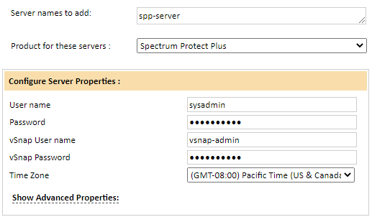

### Field Definitions

#### User Name & Password

Enter the name and password for a Spectrum Protect Plus GUI user with the required permissions. Note that the user name is case sensitive; if your SPP user name is upper case *MYUSER* then you cannot use lower case *myuser*!

#### vSnap User Name & Password

Enter the name and password for a vSnap user with the required permissions

#### Time Zone

Select the time zone where Spectrum Protect Plus server resides. This setting ensures times are displayed consistently in environments that span multiple time zones.

# Troubleshooting

If any issues are encountered with collections, please contact Bocada Support. However, here are several steps which could help diagnose any collections issues:

### Enable Logging

See the Bocada Admin Guide for the steps to enable Debug Logging.

### Enable Capture

Bocada Support may request a capture of the collection process.

1. Capture may be enabled for a Spectrum Protect Plus server by navigating to Operations > Backup Servers or Data Collection, selecting a server, and selecting Edit Server from the right Action panel.
2. In the Edit Servers dialog, on the first tab, click ‘Show Advanced Properties’.

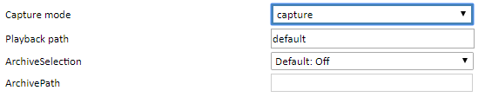

1. Edit the property ‘Capture Mode’ to “capture”
2. Manually run a collection
3. Reset the Capture Mode property back to “disable”

Capture files may be found in the Bocada installation directory of the Data Collection Server which performs collections for that Spectrum Protect Plus server, under \snapshot. By default, this will be:

C:\Program Files (x86)\Bocada\DataCollection\snapshot\SpectrumProtectPlus\<SERVER_NAME>\<COLLECTION_TYPE>\

### Run Manual Collections for short data collection periods

See the Bocada Reporting Guide for the steps to run manual collections.

Select a short date range that is wholly within a period that you previously collected data. A time-span of four hours should be sufficient, so long as there is some backup activity during that time. If you have never collected any data for this backup server before, then any short time frame will be fine. CAUTION – if you have previously collected data, and now manually collect data for a time period that does not overlap the previously collected data, you may create a gap in the collected data that must be later filled manually.

If the short collection succeeds without error, check the collection activity to make certain that jobs were found during that time-span. If not, try a different or longer time-span. If short date-ranges consistently succeed where longer date-ranges fail, the issue may simply be a very active Spectrum Protect Plus server. Consider changing the collections schedule to run collections more often.

### AuthorizationError when creating a vSnap user.

If the user that is running the “vsnap user create” is not in the vsnap group, this command will generate the following error:

ERROR: AuthorizationError: This command must be run as root or a member of the vsnap group.

To resolve, follow these steps:

1. Log into the SP+ server using the serveradmin user.
2. View the vsnap group to confirm serveradmin is a member by running the following:

grep vsnap /etc/group



1. Add serveradmin to the vsnap group by running the following:

sudo usermod -aG vsnap serveradmin

1. Confirm serveradmin is now a member of the vsnap group by rerunning the command in step 2.



1. Rerun “vsnap user create” and following the prompts.

# 

# Technical Support

For technical support or a copy of our standard support agreement, please contact us.

**E-mail:** [support@bocada.com](mailto:support@bocada.com)

**Support Portal:** https://bocada-support.force.com/s/

**Phone:** +1-425-898-24